Week 9 lecture notes
CI/CD:
- Enables automated integration and delivery
- Runs in a pipeline w/ # stages:
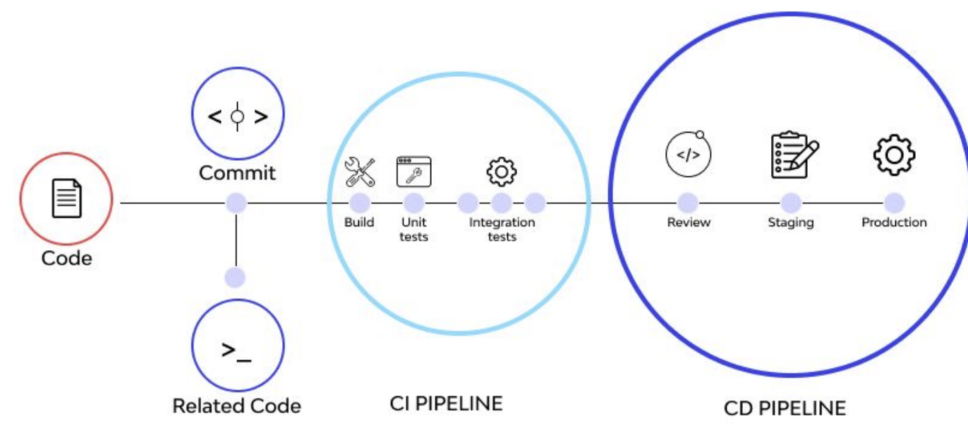
Why to use CI pipeline:
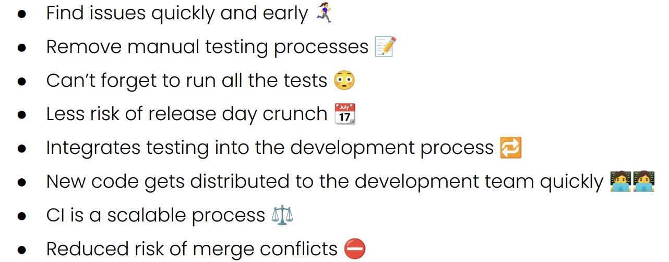

Static analysis:
- Machine assisted code reviewer
  - Checks code w/o running it
- Uses well known metrics to identify areas where code is questionable
- Done before code is tested

Why to use static analysis:
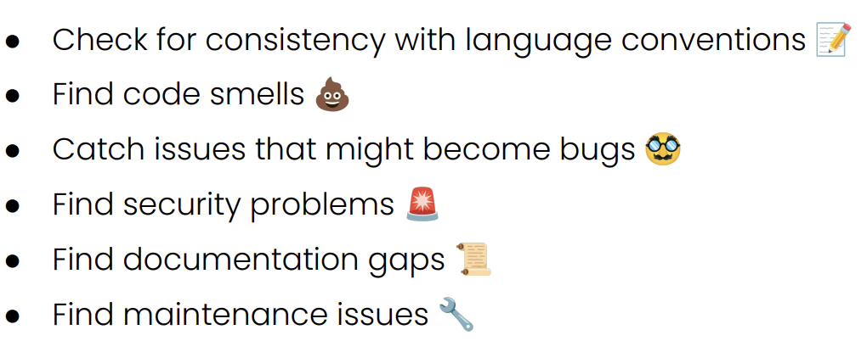

Tools for static anlaysis:
- Pylint
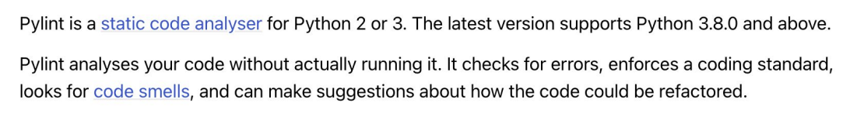
“python3 -m pylint src” gives score and the potential issues
- Take the score with a grain of salt e.g. providing a docstring will improve the score, even if the docstring = ‘’’jfoiwjfoijfieo’’’

- Pycodestyle
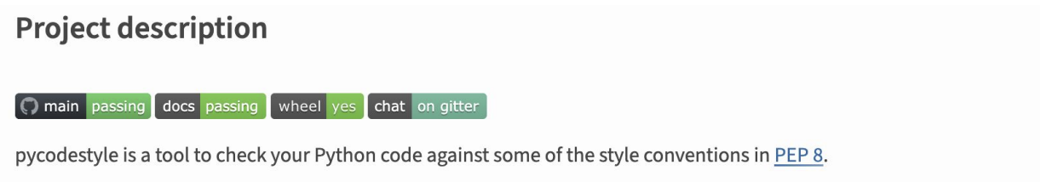
- CPD
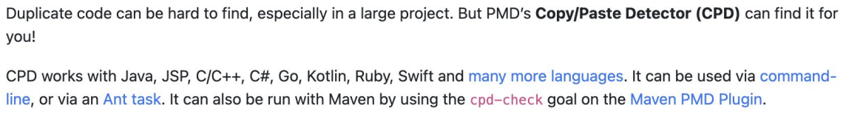

- Pydocstyle
“python3 -m pydocstyle src”

Technical debt:
- Comes from taking shortcuts
  - Writing hacky code
- Comes from time
  - Bad code now will be even badder later, coz u won’t understand it
- Also comes from:
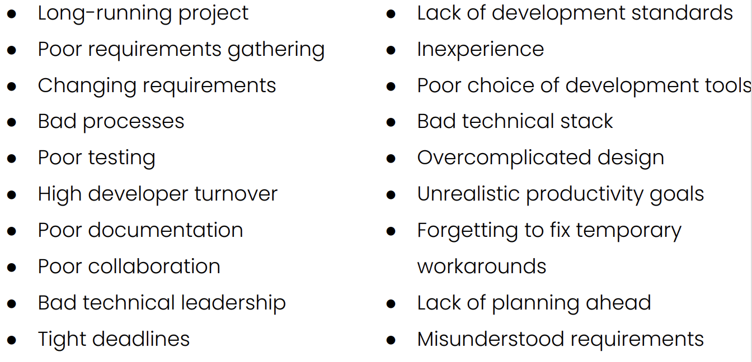
Technical debt red flags:
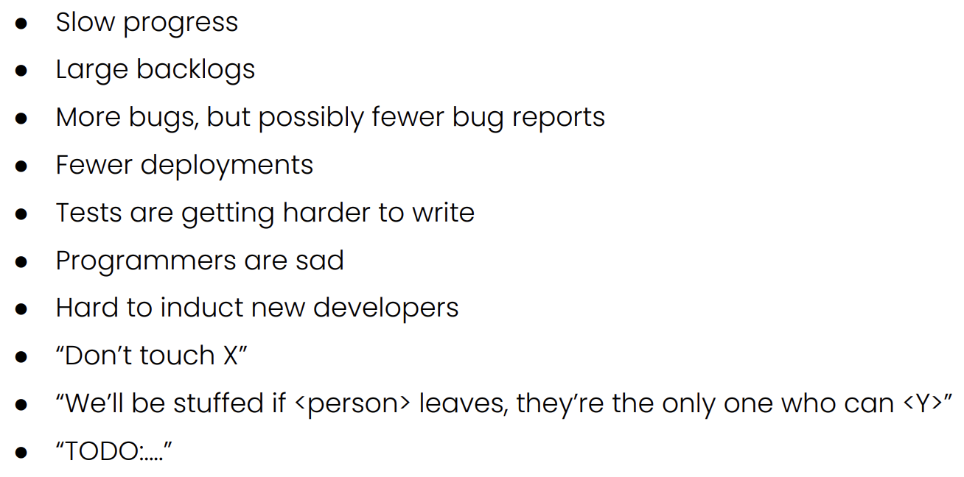

Types of technical debt:
